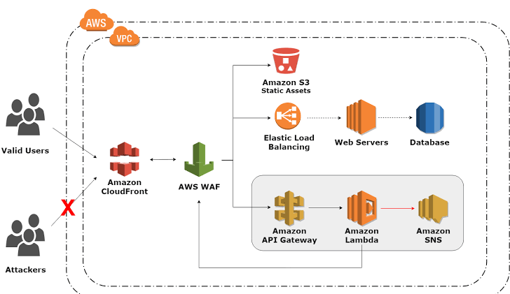

in this assignment, we have to create the web application on AWS cloud front using CI/CD pipeline and attached it to an application firewall which will host both static and dynamic websites.

we used an S3 bucket for static website hosting and Ec2 for the dynamic part which will be attached to an application load balancer. we will be using code build, code deploys, And code pipeline for it we will be using a Terraform to create an Infrastructure.

1. 

Amazon Virtual Private Cloud (Amazon VPC) enables you to launch AWS resources into a virtual network that you've defined. This virtual network closely resembles a traditional network that you'd operate in your own data center, with the benefits of using the scalable infrastructure of AWS.

1. 

Amazon CloudFront is a web service that speeds up distribution of your static and dynamic web content, such as .html, .css, .js, and image files, to your users. CloudFront delivers your content through a worldwide network of data centers called edge locations.

1. 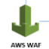

AWS WAF is a web application firewall that helps protect your web applications or APIs against common web exploits and bots that may affect availability, compromise security, or consume excessive resources.

1. 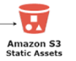

Amazon Simple Storage Service (S3) is a durable and available store, ideal for storing application content like media files, static assets, and user uploads. Storing static files elsewhere is crucial for Heroku apps since dynos have an ephemeral filesystem.

1. 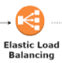

Elastic Load Balancing automatically distributes your incoming traffic across multiple targets, such as EC2 instances, containers, and IP addresses, in one or more Availability Zones. It monitors the health of its registered targets, and routes traffic only to the healthy targets.

1. 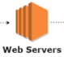

A web server is software and hardware that uses HTTP (Hypertext Transfer Protocol) and other protocols to respond to client requests made over the World Wide Web. The main job of a web server is to display website content through storing, processing and delivering webpages to users.

1. 

Amazon Web Services Simple Notification Service (AWS SNS) is a web service that automates the process of sending notifications to the subscribers attached to it. SNS provides this service to both application-to-person and application-to-application. It uses the publishers/subscriber’s paradigm for the push and delivery of messages. The data loss is prevented by storing the data across multiple availability zones. It is cost-efficient and provides low-cost infrastructure, especially to mobile users. It sends the notifications through SMS or email to an Amazon Simple Queue Service (SQS), AWS lambda functions, or an HTTP endpoint.

1. 

CI and CD stand for continuous integration and continuous delivery/continuous deployment. In very simple terms, CI is a modern software development practice in which incremental code changes are made frequently and reliably.

1. Variables in Terraform are **a great way to define centrally controlled reusable values**. The information in Terraform variables is saved independently from the deployment plans, which makes the values easy to read and edit from a single file.
2. **Policy can include imports which enable a policy to access reusable libraries, external data and functions**. Terraform Cloud provides four imports to define policy rules for the plan, configuration, state, and run associated with a policy check.